LAB 6 AOP

Add AOP functionality to the Solution of Lab 4.

Add Maven dependencies

Add Configuration in XML file.

Disable Hibernate Show SQL

1. Create AuctionAspect.java

Add an implicit Pointcut [execution] that looks for all Service methods.

Use it in a Before advice type on an Advice method that Prints out Method name.

Verify that it generated a message for all the Service method calls [~ 12].

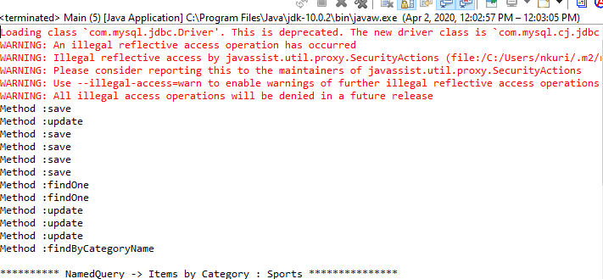

1. Make the pointcut into an explicit pointcut.

Validate that it works.



1. Change the pointcut arguments from (..) to (Long)

What is the result?

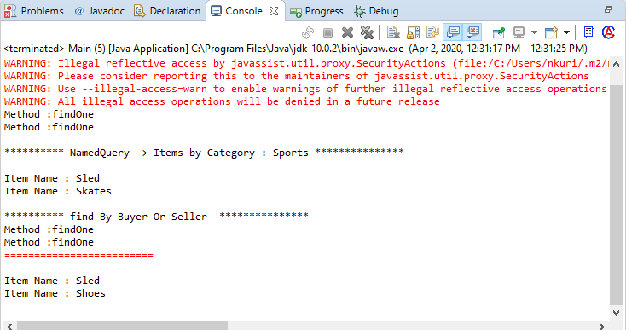

1. Change the pointcut arguments from (Long) to ()

What is the result?

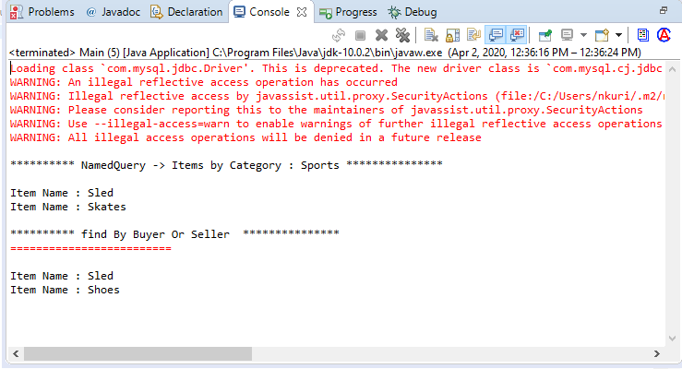

1. Add a findAll() to testItems.java

Now what is the result?

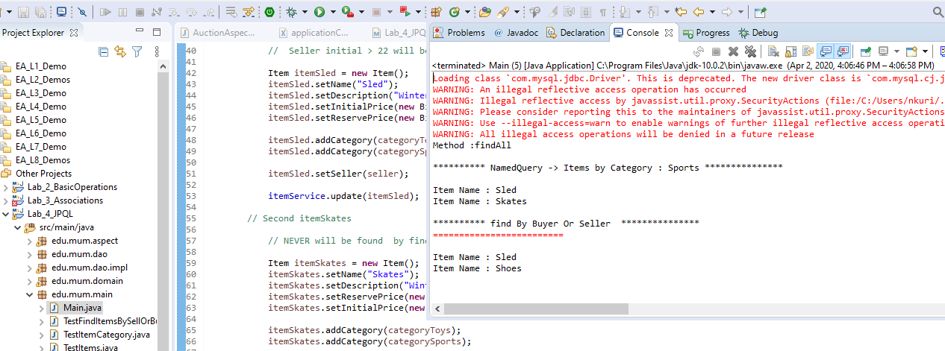

1. Replace the execution pointcut with a combination of a within() and an args() pointcut

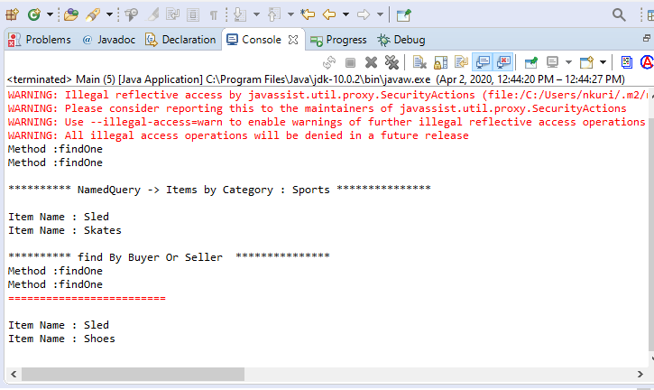

1. Add another Advice method with a User parameter:

**public** **void** logResourceName(JoinPoint joinPoint, User user) {

use an explicit pointcut with a combination of a within() and an args(user).

**[ be sure to printout user name from advice method]**

